Climate Change:
It's the Sun, Stupid!
The
Kyoto Premise
is a
Drug Trip
by
Scientists,
Policy Analysts, &
Environmentalists

that man-made Green-House Gases (GHGs) [have had/ are having/ will have] a catastrophic impact on the climate, environment and mankind,

government and academic research

it is amplified by government

of course, it is taken to a lunatic scream by
Luckily, there are a few rare scientists in academia (even less from the government labs) who are trying to bring Science back into "Climate Science". Five to ten Canadian academic scientists are globally renowned for challenging the Kyoto Premise.

In the end, it's possible that the "Kyotoists" may be proven to be correct, but the probability looks extremely low. And if they have guessed right it will have been by sheer accident, not by rational thinking based on the data and any coherent analysis, which point in entirely different directions!

Most people are believers.
There are very, very few critical thinkers.
Most scientists are like most people.

T-shirt design available at www.BillHowell.ca/docs/Howell - T-shirt, Kyoto fraud.pdf

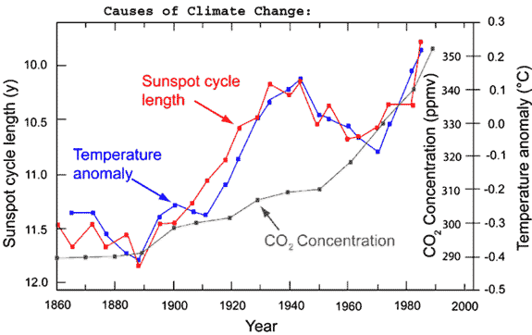
Lies, Damned Lies, and Scientists
UN-IPCC 1990
UN-IPCC 2001 hockey stick
relative forcing Wm-2
UN-IPCC 2001

Water vapour is 90 - 95% of the GreenHouse Gas (GHG) effect!!
(CO2 is only ~4% of the effect)
The "Hockey Stick" fraud for the last 1,000 years (UN-IPCC driven, National Academy of Sciences supported)
The CO₂ fraud for the Modern Warm Period We see the splicing of different data series together, and selective throwing out of data. Since the heat absorption is nearly complete for carbon dioxide in its absorption band, adding more carbon dioxide to the atmosphere does not appreciably increase its global heat retention effect. (from Borello)
years AD 1000 1200 1400 1600 1800 2000
Temperatures during the Modern Warm period (~1850 on) follow the sun! CO₂ isn't relevant.

Ice core data from glaciers shows that CO₂ concentrations are a function of temperature, not the other way around! (dates in ky BP)
Glaciation cycles (black) & Global solar insolation (blue)

