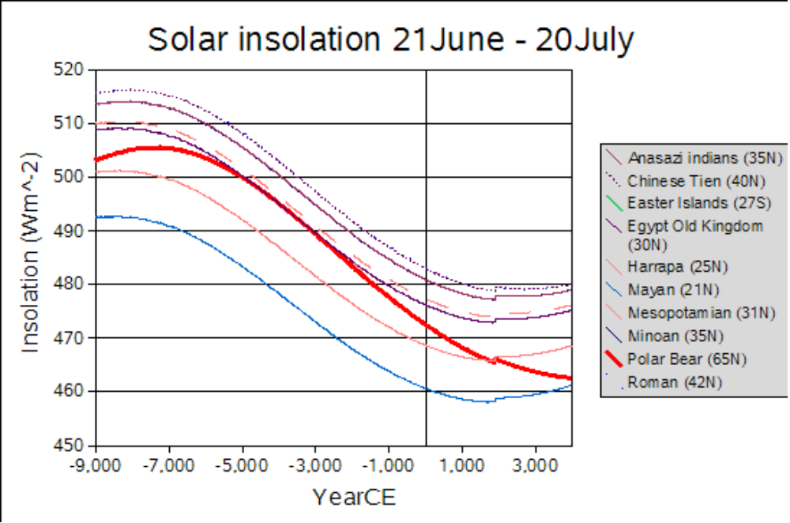
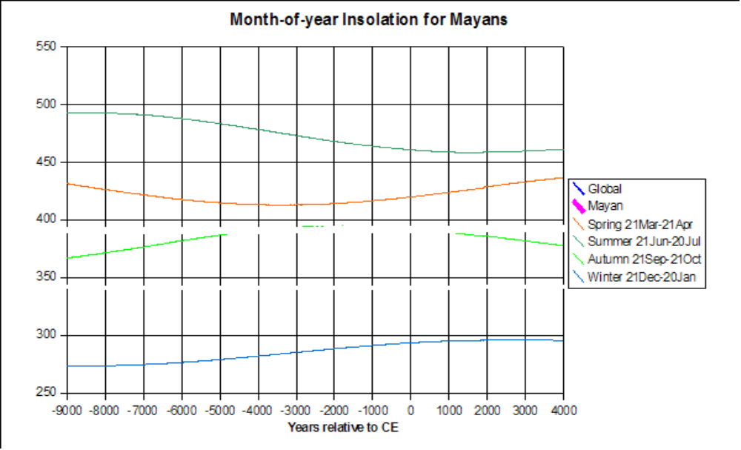
Initial graphs on the Solar influence on civilisations

The "jumps or blips" are due to assuming solar irradiance = 1368 Wm^-2 from 1895 on - must update some time.
Easter Islands is in the Southern Hemisphere - different y-axis scale for Jun-Jul

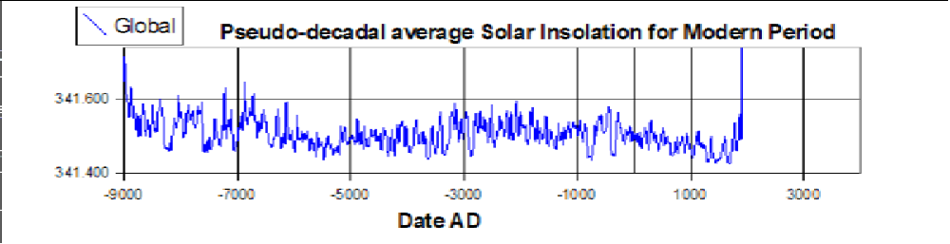

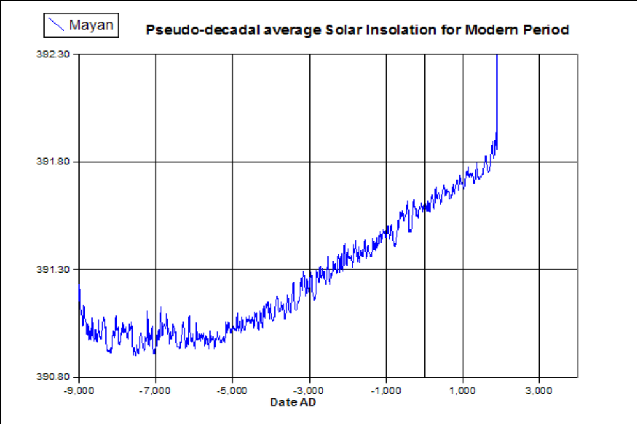

Is the "linear rise" in "unsquashed" (sort of decadal beefed up to annual variability) decadal average insolation real, or an error of data treatment? (to check later) Graphs "scaled" to show same sized peaks on global and regional graphs.

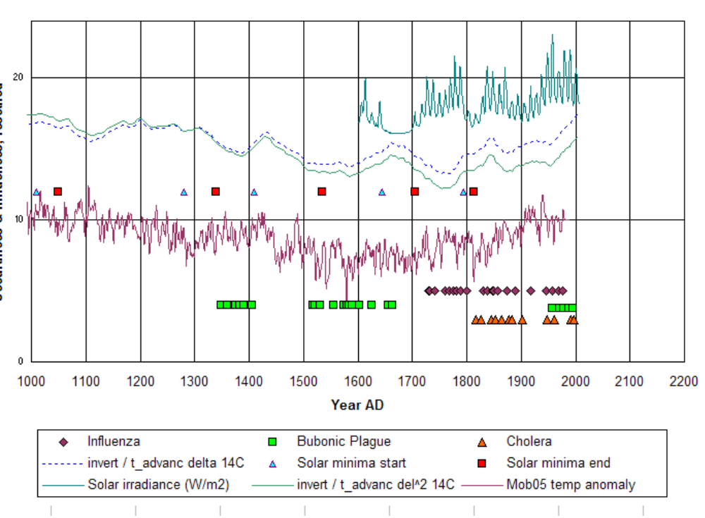
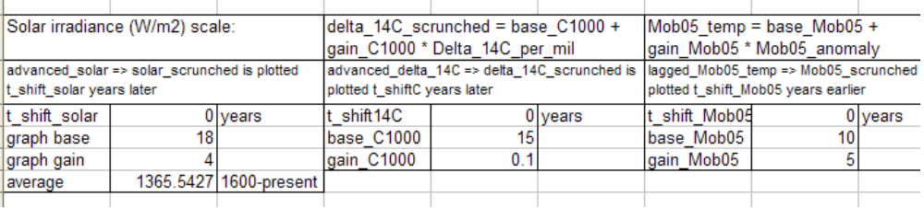
Earlier graphs!



