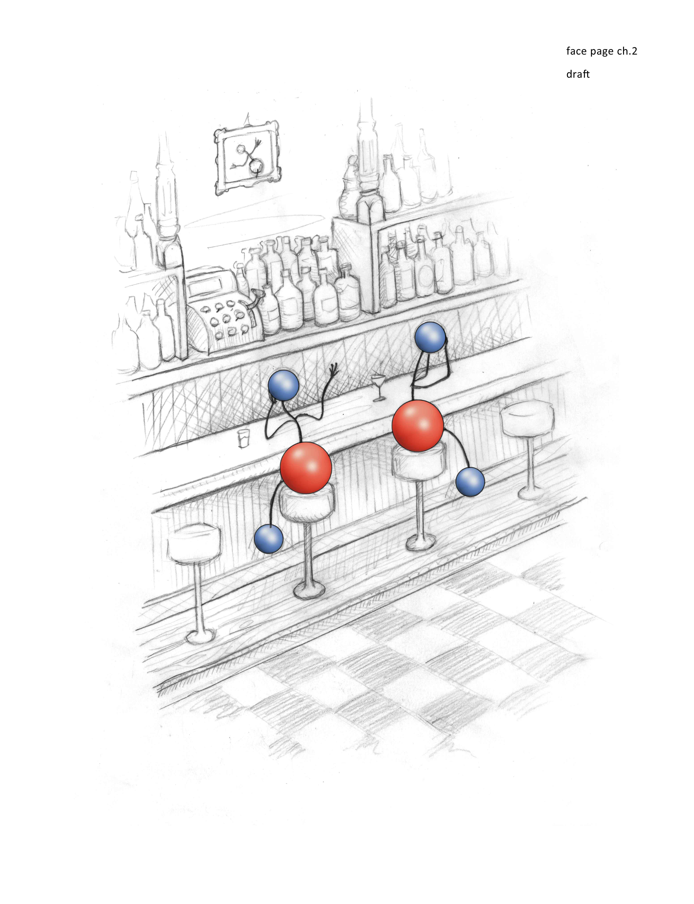
Chapter 2
The Social Behavior of H₂O
Water is central to life — so much so that the father of modern biochemistry, Albert Szent-Györgyi, once opined: “Life is water dancing to the tune of solids.” Without the dance of water, there could be no life.
Given this centrality, you’d expect that by the 21st century we’d know pretty much all there is to know about water. Yet oddly, this is not the case at all. Consider what Philip Ball has to say on the issue. Ball is one of the premier science writers of our time, author of H₂O: A Biography of Water, and a long-time science consultant for the journal Nature. Ball puts it this way: “No one really understands water. It’s embarrassing to admit it, but the stuff that covers two-thirds of our planet is still a mystery. Worse, the more we look, the more the problems accumulate: new techniques probing deeper into the molecular architecture of liquid water are throwing up more puzzles.”
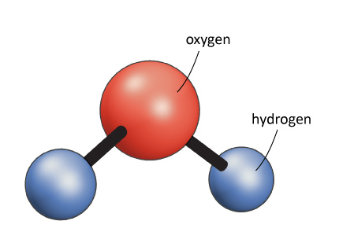
Please don’t misunderstand. The water molecule itself is pretty well understood. Consisting of two hydrogen atoms and one oxygen atom, the molecule is arranged in a configuration that you might have seen in textbooks (Fig. 2.1). There’s no reason to doubt that configuration. What we don’t know is how a water molecule interacts with other water molecules or with molecules of other types. Water’s social behavior is the mystery that lingers.
Most people have not thought much about the interactions among water molecules; they merely assume that the water molecules exist. Biologists, for example, often regard them as background molecules — the vast molecular sea that bathes the more important molecules of life. We do not picture water molecules as interacting with anything.
But they absolutely do interact, even with one another. Consider the ordinary water droplet. At least some of the billions of molecules that make up the droplet must stick to one another, for without that cohesion there could be no droplet. Exactly how those H₂O molecules work together to produce the recognizable droplet remains unclear to scientists. They cannot agree on a coherent theory of the “social behavior” of water molecules — how they interact in ways that produce familiar entities like droplets, clouds, or narrow, streams of falling water.
Figure 2.1. Artist’s sketch of the water molecule.
The Current Status of Understanding
The paradox of why the behavior of our planet’s most common molecule continues to be so poorly understood has several root causes. Surprisingly, the reasons are not purely scientific. They are partly scientific for sure, but also partly psychological (who cares about anything so mundane as water?), partly political (our country’s scientists are superior to yours), and partly social (a few sagas that could be the stuff of novels).
Before I deal with these human aspects of the paradox, I do want to say a few words about our provisional understanding of water interactions, i.e., what we think we know. Although a hodgepodge of ideas, what follows is a brief précis of current thinking. Please don’t worry if you find it difficult — the theories are complex, and even water scientists occasionally have difficulty understanding one another’s theories. So, I will keep it brief. Readers seeking a more comprehensive understanding might find useful a detailed review (Ball, 2008). Here I merely outline how today’s prominent scientists think water molecules interact with one another (Fig. 2.2).
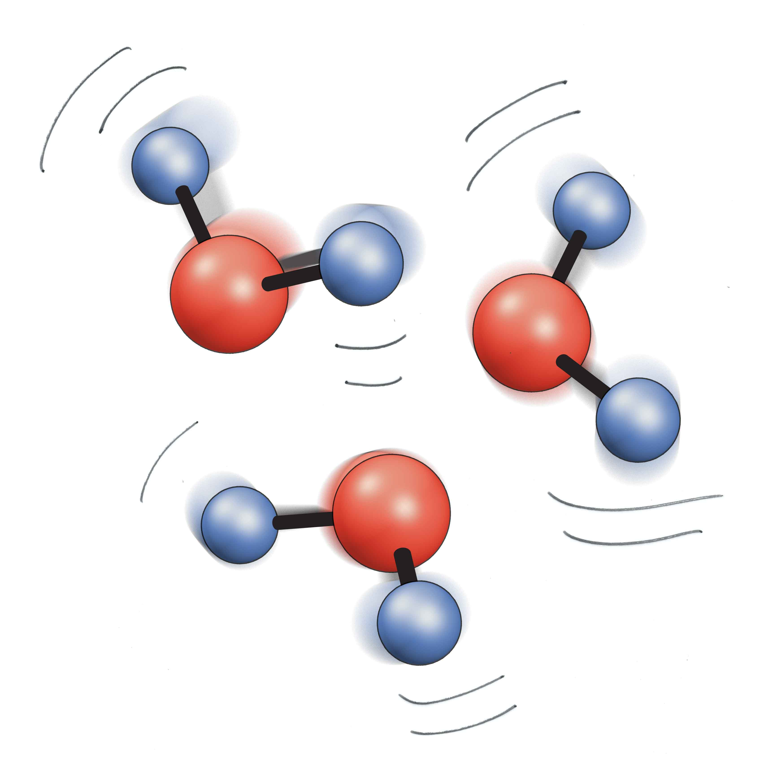
The classical view of water-water interaction is the “flickering cluster” model introduced in 1957 by Frank and Wen. In this model, clusters of water molecules grow on a time scale of 10⁻¹⁰ to 10⁻¹¹ seconds. Water molecules surround each cluster. Positive feedback makes the clusters grow and then subsequently disperse; hence, they flicker. Although outdated, this model still appears in many textbooks.
Martin Chaplin of London South Bank University, England, presents a slightly more organized model. Chaplin suggests that liquid water consists of two types of intermixed nano-clusters. One is an empty, shell-like cluster, more-or-less collapsed, while the other is more solid and more regularly structured. Molecules of water switch their allegiance rapidly between these two phases, although, under a given set of conditions the average number in each category remains the same. Those interested in this model can find details, and very much more about water, on Chaplin’s famously informative website (Web ref. 2.1).
Figure 2.2. Interaction among water molecules.
Quite a different picture emerges from the work of Anders Nilsson of Stanford University and Lars Petterson of Stockholm University. Their model also posits two coexisting types of water: ice-like clumps or chains containing up to about 100 molecules; and a disordered type of water that surrounds those clumps. The authors envisage a kind of disordered sea containing rings and chains of hydrogen and oxygen atoms.
A much larger scale of clustering characterizes the model of Emilio del Giudice of the University of Milan. Based on quantum-field theory, del Giudice posits large coherence domains of water, each of which may contain many millions of molecules. Bonds between the water molecules in those domains may be thought of as antennae that receive electromagnetic energy from outside. With such energy, the water molecules can release electrons, making them available for chemical reactions.
A popular model that builds explicitly on the associations inherent in all of the foregoing models is the one advocated by Gene Stanley of Boston University. Stanley suggests that water has two distinct states, low density and high density. The distinction appears most clearly when water is super-cooled. Low-density water has an open tetrahedral structure, while high-density water has a more compact structure. The two dynamically interchange with one another.
Another two-state model emphasizes that water molecules can exist as mirror images. That is, one fraction of water molecules is left-handed, while the other is right-handed. Major proponents of this kind of model include Sergey Pershin from Moscow and Meir Shinitzky and Yosi Scolnik from Israel. They argue that the relative proportions of these two species can explain diverse features of water.
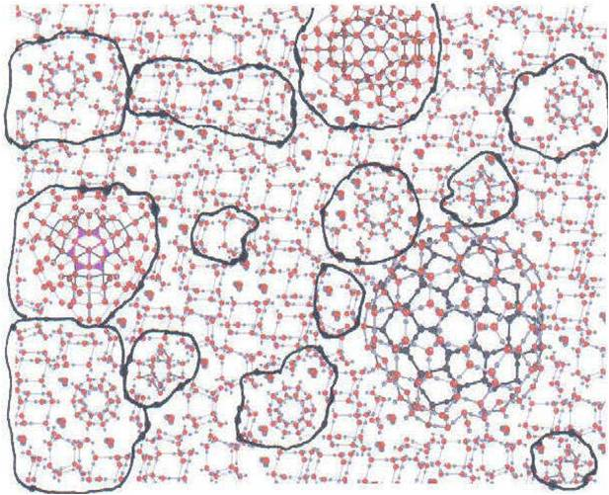
The most complex model, put forth by the late materials-science pioneer Rustum Roy, emphasizes the heterogeneity of water structure, as well as the ease of interchange. Interchanges require very little energy. A cartoon schematizing some representative structures is shown in Figure 2.3.
By now, you probably feel you have heard enough. Yet this sampling is merely representative of a larger group. While the molecule’s composition is well known, the issue of how those molecules interact with one another and with different molecules nearby is continually debated. The state of water is a state of confusion or, as Ball puts it, still a “mystery.”
Figure 2.3. Proposed structure of liquid water, from Roy et al, (2005). Clusters are outlined in black.
Why We Understand So Little

Water once occupied a central position in scientific research. In the early 20th century scientists focused on uncovering general principles of nature rather than adding detailed knowledge to narrowly defined areas. The whole seemed more important than its molecular parts. That whole surely had to include water because of its pervasiveness throughout nature.

It was also a time when colloids, submicroscopic particles suspended in a liquid, seemed important. Believing that life was built on a colloidal foundation, many scientists assumed that knowledge about how colloids interacted with water would lead to an understanding of the basic chemistry of life. The colloidal focus, combined with the holistic approach of the era, put water at the center of scientific research.

But two things happened along the way that blighted the promising harvest. First, the shift toward specialization drew scientists away from the holistic approaches that had to include water, toward more molecular approaches that assigned water a more secondary role. Molecules became the rage. The more you understood a molecule, the closer you approached scientific truth. Inevitably, water research became old-fashioned and gradually lost its prominence.
The second happening was more socio-political. It involved two incidents, each of which had a terrible dampening effect on progress.
The first was the so-called “polywater debacle.” It began in the late 1960s with a Russian discovery that water confined within narrow capillary tubes behaved differently than ordinary water: Its molecules vibrated differently; its density was anomalously high; and it was difficult to freeze or to vaporize. Clearly, this was some exotic brand of water. Because its properties implied high stability similar to common polymers, chemists thought of it as polymer-water and coined the ultimately fateful descriptor, “polywater.”
The discovery of polywater triggered excitement among many scientists — imagine, a new phase of water. But there was also skepticism, and the Russians eventually wound up embarrassed when Western scientists identified an insidious problem: impurities. The supposedly pure water inside those capillary tubes was shown to contain salts and silica leached from the surrounding glass tubes; those impurities had apparently given rise to the exotic features that were reported. Even Boris Derjaguin, the legendary physical chemist responsible for most of the initial studies, would admit publicly that the impurities had been present. The skeptics could find justification in their initial reaction that “polywater was hard to swallow.”
I’ll have more to say later on polywater, particularly on the role of US-Soviet politics in Derjaguin’s recantation. I will mention here that “contaminants” are bugaboos that plague all scientific fields. A scientist hopes for something pure, but absolute purity is challenging to attain. In the case of water, achieving purity is virtually impossible because water is a natural solvent for almost everything: it has a propensity to absorb all kinds of foreign molecules. In this sense, contaminants are natural features of water, and their presence in limited quantities does not necessarily imply that any observed feature needs to be reflexively discarded.
However, the damage was done by the late 1960s; the Russians were deemed guilty of careless experimentation. The injury to the field grew far out of proportion to the indictment’s significance, mainly because of the extreme publicity given to polywater. The press had caught hold, leading to the inevitable sensationalization. Imagine, they suggested: a drop of polywater thrown into the sea could act like any polymeric catalyst: that single drop could polymerize the earth’s entire water supply into a single blobby mass, which would abruptly end all life. Dangerous stuff, for sure (Fig. 2.4).
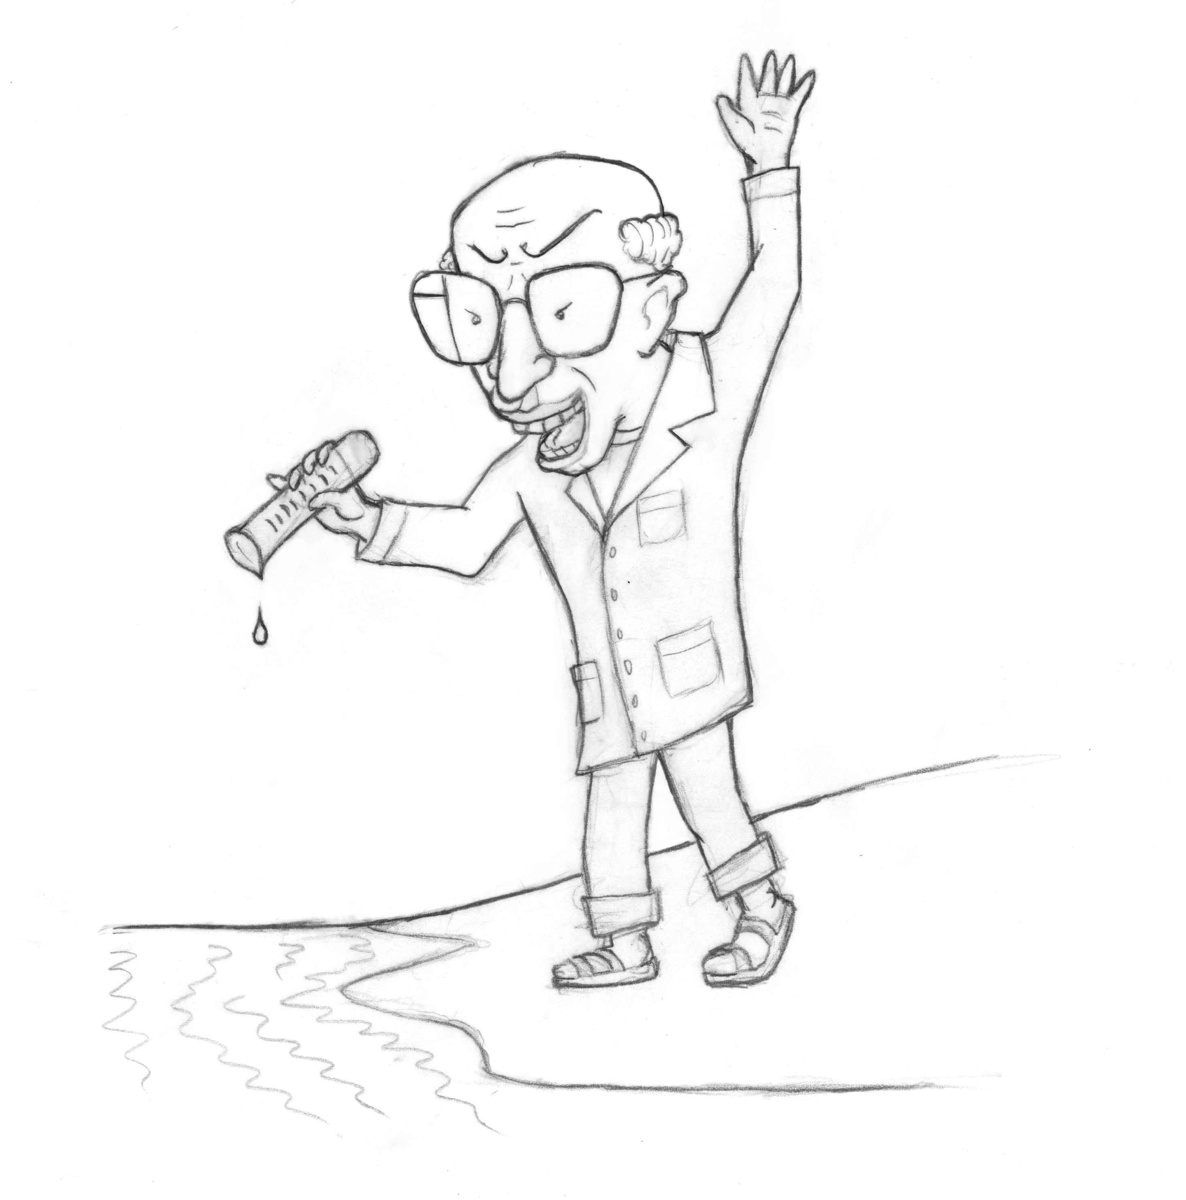
The public was therefore relieved by the reports of the contamination error. Other, less paranoid folks felt disappointed that this exciting new scientific finding turned out to be nothing more than an experimental flub. Either way, water scientists were clearly incompetent.
The instantaneous catastrophic impact on all water research is not difficult to imagine. If Russia’s premier physical chemist could go so easily astray, then what about more ordinary scientists? The risk of embarrassment seemed high. Talented scientists who might have pursued water research opted for safer terrain in order to avoid the possible taint of polywater.
Figure 2.4. The specter of polywater.
So, largely out of fear, water research almost ground to a precipitous halt. A few brave diehards persisted, mainly in the domain of biological water, but the momentum was killed. The lingering mystery of water was left for others to resolve, sometime in the vaguely distant future. The field became moribund and, as a definable scientific discipline, dead.
The Water Memory Debacle
Two decades later there were signs of an incipient recovery — until, that is, an even deadlier blow struck: the so-called “water memory” debacle. Here, the central figure was the late French scientist, Jacques Benveniste, a renowned immunologist. Almost by accident, Benveniste and colleagues obtained evidence that water could retain information from molecules with which it interacted. Water, you might say, could “remember.”
The evidence came from experiments involving successive dilutions. Take a substance dissolved in water and dilute it ten times. Then repeat the dilution again and again. Once you dilute enough times, all you have left is water; statistically, none of the original substance remains. Benveniste and colleagues would dilute it even well beyond that stage of nothingness, and still the solution could have as much biological impact as the original. In other words, pouring either the concentrated substance or the serially diluted substance onto various cells could trigger the same molecular dance. It appeared that the diluted water retained a memory of the molecules with which it had been in contact, for only those molecules were specific enough to initiate the dance.
Preposterous, thought the editor of Nature, Sir John Maddox. How on earth can water retain information? But not everyone shared that seemingly obvious response. Homeopaths use much the same procedure for preparing their remedies, and some members of the homeopathic community felt that finally, a distinguished scientist had vindicated their approach. Benveniste himself was less interested in homeopathy than in science. Reacting to the summary rejection of his findings by Nature, he asked colleagues in three other laboratories to repeat his experimental protocols to see if they obtained the same results.
Remarkably, they did. And, once again, a report of the findings was submitted to Nature. The journal responded the same as before. Evidently, no matter how many laboratories reproduced the results, these findings looked so improbable that some experimental gremlin must clearly have been lurking in the diluted water. The polywater incident was still very much in mind, and Nature smelled a rat.
Under pressure to act fairly, the journal finally agreed to publish the results, albeit with one condition; the editor reserved the right to summon a committee to look leisurely over the shoulders of the French scientists as they performed their experiments. The committee would report back to the readers of Nature. The French group accepted the stipulation, and the paper quickly appeared, along with an appended disclaimer of skepticism. The editor indicated that he would launch an investigation by a committee of peers to determine just what those French scientists were really up to.
The committee of peers was in fact a committee of sleuths. Along with editor Maddox, two additional people were asked to investigate. One, Walter Stewart, worked at the US National Institutes of Health in a special division dedicated to uncovering scientific fraud. In other words, he was a professional sleuth. The other was James Randi, otherwise known as “The Amazing Randi.” A world-class stage magician, Randi earned his fame by debunking the tricks of other magicians, such as Uri Geller’s claim that he could levitate. Judging from the makeup of this committee of “peers,” it was clear that Maddox suspected more than just an innocent error.
The committee came to Paris and carefully watched the experiments. The first sets of experiments went pretty much as claimed. The French seemed to prevail in the early rounds. But, when one of the visitors himself performed the dilutions, the results did not go as well. The visitors huddled, and quickly concluded that, since the French could produce the claimed result but the visitors could not, then clearly a trick was involved. The nature of the trick remained unclear to the professional debunkers. Nevertheless, their report to the world of science boldly declared that water memory was a “delusion.”
This colorful story is rich with detail, and for more of that detail I recommend two books, written by authors close to the principals. I already have recommended the book by Philip Ball, who worked for Nature at the time. The late physicist Michel Schiff wrote the second one, entitled The Memory of Water. He worked in the French laboratory at the time of the incident. As you may imagine, these authors have rather different sympathies; to get the full picture you should read both books.
Benveniste suffered widespread humiliation, loss of grant support, collapse of a large and productive laboratory, difficulty publishing any further scientific work, and — the ultimate ignominy — twice winning the “Ig-Nobel” Prize awarded by Harvard students for improbable research.
However, the main point here is neither the ugliness of the incident nor the instant demise of an illustrious scientific career. The main point is the impact on the field of water research. Barely recovering from the polywater debacle, the field suffered this second and even more devastating setback. Water memory became the laughingstock of the entire scientific community. Finding it hard to remember names? Try drinking more water. (Ha, ha!)
Given this situation, can you imagine how many scientists of sound mind would dare enter a field first tainted by polywater and then debased as the butt of scientific jokes? Very few, indeed. Yet, others would later confirm Benveniste’s result (Walach et al., 2004), and still others including Nobel laureate Luc Montagnier would eventually build on it to claim transmission of information stored in water (Montagnier et al., 2011). Despite all that, water memory remains to this day a joking matter rather than a subject of serious scientific investigation.
The Mystery Lingers
I think you can understand how we have come to know so paradoxically little about something so familiar as water. Two successive debacles turned a once-dynamic field into treacherous domain, into which few scientists have had the temerity to enter.
But those two incidents alone were not fully responsible for the damage. The shifting culture of science also played a significant role. During the latter part of the last century the scientific culture became increasingly specialized. “Experts” began playing dominant roles. Their narrowly focused expertise pushed out the more global approaches commonly used to investigate water; hence, water research grew unfashionable. Couple this cultural shift to the two off-putting debacles and you can understand why the field of water research practically dried out.
Rising from its ashes is the current field of water research, which is best described as schizophrenic. On the one side, mainstream scientists employ computer simulations and technologically sophisticated approaches to learn more about water. Their results more or less define the field. These approaches are relatively risk-free, and provide incremental advances that help refine the various models outlined at the beginning of the chapter.
On the other side, the more provocative studies investigate what chuckling mainstreamers like to call “weird water.” This research centers on observations that seem by conventional standards to be odd or anomalous (see Chapter 1). Anomalies once provided tantalizing clues for scientific understanding. Today’s mainstream water scientists, however, fearful of yet another wounding debacle, often relegate them to fringe science. They are placed in the same category as cold fusion, UFOs, and subtle energies. If you want to retain your scientific respectability, you’d better keep your distance.
Given such an atmosphere, you can surely appreciate why building understanding has become a challenge. Conducting fundamental research on water is something like walking in mud. You might pick up a few submerged nuggets of understanding here and there and from them try to build an edifice of understanding. This slow, arduous process makes it difficult to lay even a primitive foundational basis.
***
In the chapters that follow, we deviate from this well trodden muddy pathway and forge an entirely fresh one. We exploit clues that others have ignored in order to build understanding. Given the simple nature of a single water molecule, we take the position that its social behavior cannot be as complicated and confusing as presented by mainstream models. If nature is simple and intuitive, then surely its most ubiquitous component must be equally simple and intuitive. We set out to uncover that simple understanding.

References
Ball, Philip: H2O: A Biography of Water. DETAILS???
Roy, R, Tiller, WA, Bell, I, Hoover, MR (2005). The Structure of Liquid Water; Novel Insights From Materials Research; Potential Relevance to Homeopathy. Materials Research Innovations Online 577-608.
Schiff, Michel, The Memory of Water, Thorsens, Year..
Montagnier, L, Aissa, Del Giudice, E, Lavalee, C, and Tedeschi, A (2011). DNA waves and water. J. Phys. DETAILS??
Walach, H, Jonas, WB, Ives, J, Van Wijk, R, Weingartner, O, (2005). Research on Homeopathy: State of the Art. J. Alt. and Comp Med. 11(5) 813-829.

Ball, P. (2008). Water as an Active Constituent in Cell Biology
Chem. Rev. 108, 74−108.

Web reference 2.1: <http://www1.lsbu.ac.uk/water/>

